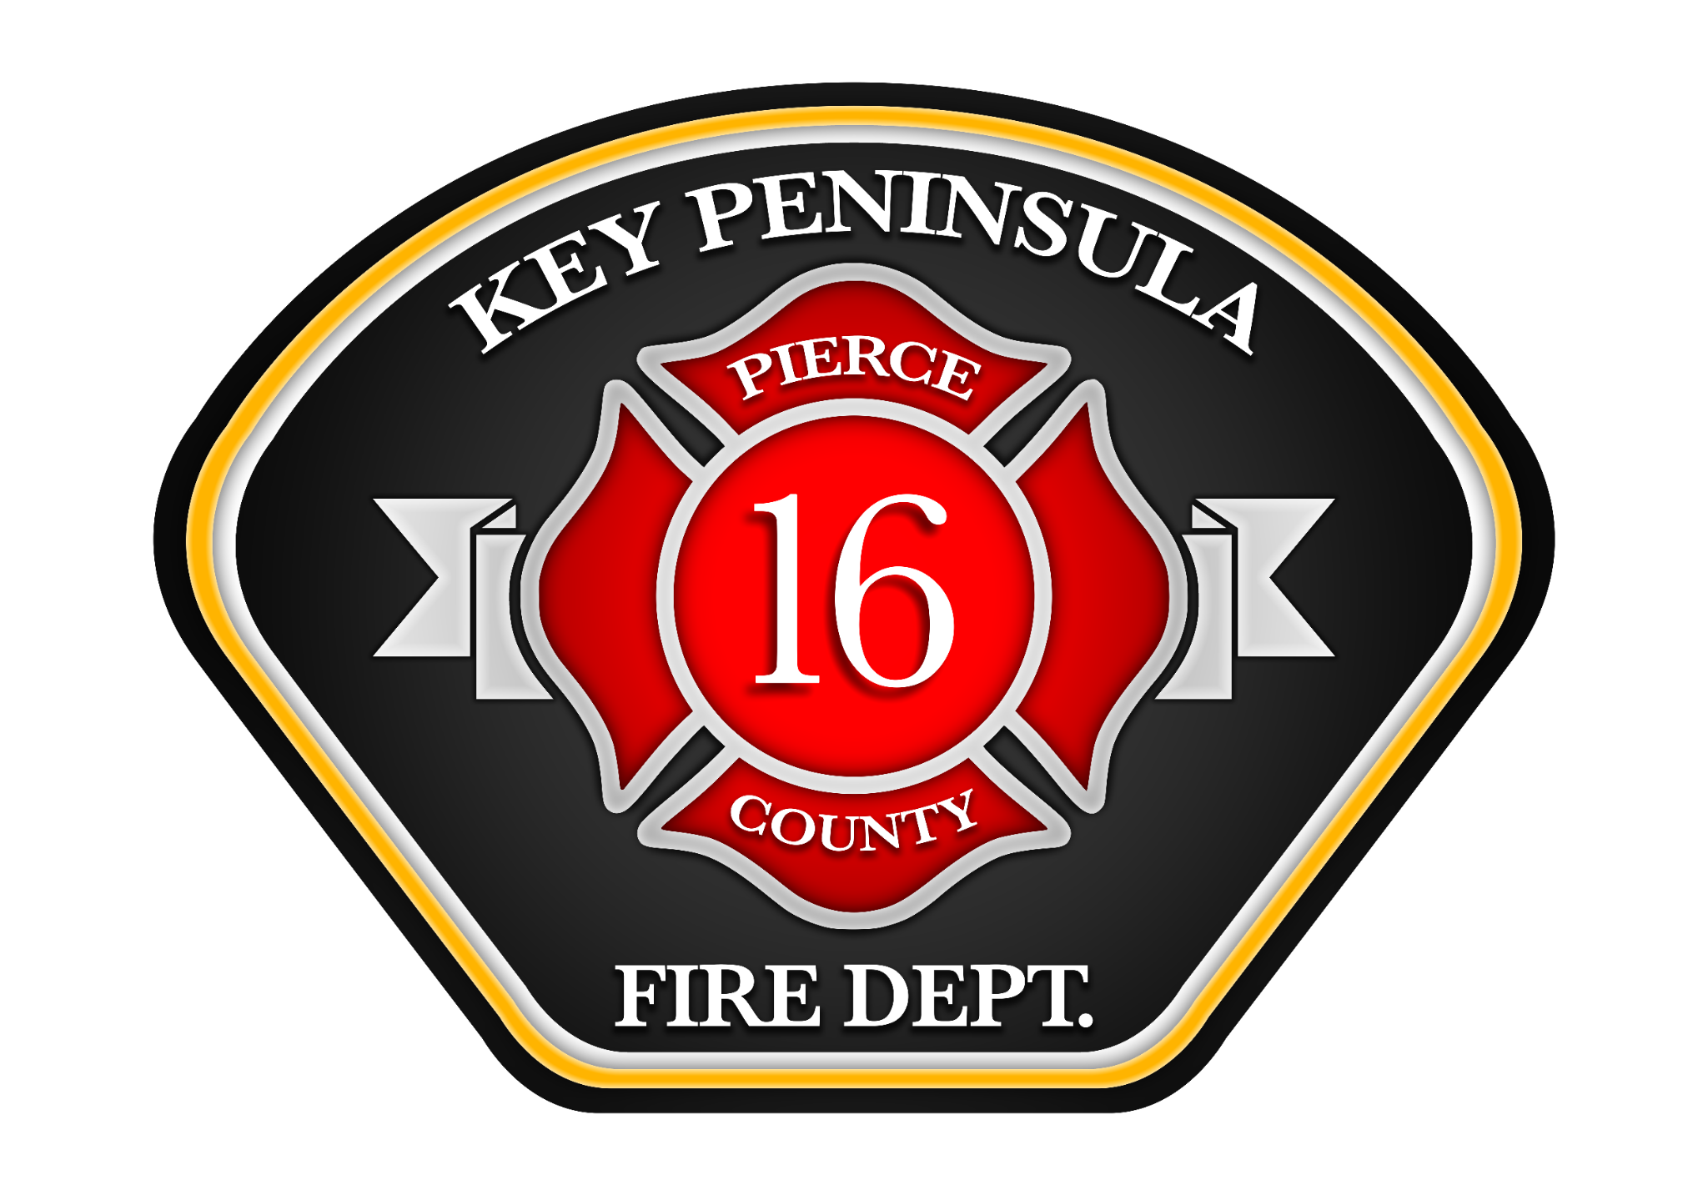

KEY PENINSULA FIRE DEPARTMENT
Lateral Firefighter/EMT & Lateral Firefighter/Paramedic Recruitment
The Key Peninsula Fire Department is accepting applications for Lateral Firefighter/EMTs and Lateral Firefighter/Paramedics to join our dedicated and progressive team serving the Key Peninsula community.

Application Process
Applications can be downloaded at www.keypeninsulafire.org
To be considered, applicants must submit:
• Completed application
• Cover letter
• Resume
Application Deadline: Applications must be received by 5:00 p.m. on December 4, 2025.
Submission Options:
• Email: info@keypeninsulafire.org
• Mail: 8911 Key Peninsula Hwy NW, Lakebay, WA 98349
• Hand Delivery: Same as mailing address
Qualified applicants will be notified via email regarding the next steps in the hiring process.

Minimum Requirements
• Be at least 21 years of age
• Possess a high school diploma or GED
• Possess or be able to obtain a valid Washington State driver’s license
• Have no felony or criminal convictions
• Have no outstanding warrants or pending criminal charges
• Be able to read, write, and speak the English language
• Be a U.S. citizen, legal resident, or legally eligible for employment in the U.S.
• Possess a current Washington State or National Registry EMT certification (or higher) prior to hire

Lateral Hire Requirements
• Must have successfully completed a full-time career structural fire academy (or equivalent)
• Must have at least 12 consecutive months of full-time structural firefighting experience
• Must be currently employed as a full-time firefighter, or have been separated in good standing within the past 18 months
• Must possess a current National Registry or Washington State EMT or Paramedic certification
• Must hold IFSAC or ProBoard certification in:
• - Hazardous Materials Awareness/Operations
• - Firefighter I (Firefighter II preferred)

Salary and Benefits
• $6,655 – $9,507/month (DOE)
• Additional 12% premium pay for Paramedics
• 48/96 shift schedule with 16 Kelly Days
• 100% employer-paid medical insurance for employee and family
• 6% employer-matched 457 plan
• Generous vacation, holiday, and sick leave package
• Wellness incentive, tuition reimbursement, and education premium pay

For questions or additional information, please contact info@keypeninsulafire.org.

